SIMATS ENGINEERING
ASSESSMENT TOOL 2 - Pseudocode Writing Task

COURSE NAME: STATISTICS WITH R PROGRAMMING COURSE CODE: ITA04

COURSE OUTCOME COVERED

CO 1: Apply R programming fundamentals including data structures, vectors, matrices, arrays, and class types to perform mathematical operations and manage data effectively.(Bloom Level-BL2-BL4)

Assessment Tool Weightage: 20%

QUESTIONS:

Total Marks: 100

1. Variables and Data Types Analysis (BL4 - Analyze)

  - Design pseudocode to simulate basic variable handling in R programming:

  - Declare variables of different data types (numeric, character, logical)

  - Perform arithmetic and logical operations

  - Display the results

2. Data Structures Implementation (BL4-Analyze)

  - Write pseudocode to demonstrate advanced data structures in R

  - Create and initialize a vector, list, and matrix

  - Perform operations such as indexing, updating, and aggregation

  - Compare the structures based on usage

3. Matrix and Array Operations (BL4-Analyze)

  - Design pseudocode to perform operations on matrices and arrays:

  - Create a matrix and a 3D array

  - Perform addition, multiplication (matrix), and element-wise operations

  - Display the results and analyze differences

4. Data Frame Construction and Manipulation (BL4-Analyze))

- A dataset needs to be organized efficiently.

- Write pseudocode to:

- Create a data frame with multiple columns (numeric and character)

- Add, delete, and modify columns

- Perform basic summary operations

5. Functions and Logical Operations (BL4-Analyze)

  - Design pseudocode to implement functions and logical vector operations:

  - Create a user-defined function with input parameters

  - Perform operations on logical vectors

  - Return and display computed results

Code of Conduct:

I R.SHARMILA(192521213) (Name/Reg No) certify that this submission is my original work and that I have adhered to the guidelines specified for this assessment.I understand that any violation of academic integrity rules will result in disciplinary action.

Signature of the student:

Q1)Variables and Data Types Analysis

This question demonstrates numeric, character, and logical variables. Arithmetic and logical operations are performed and the results are displayed using R.

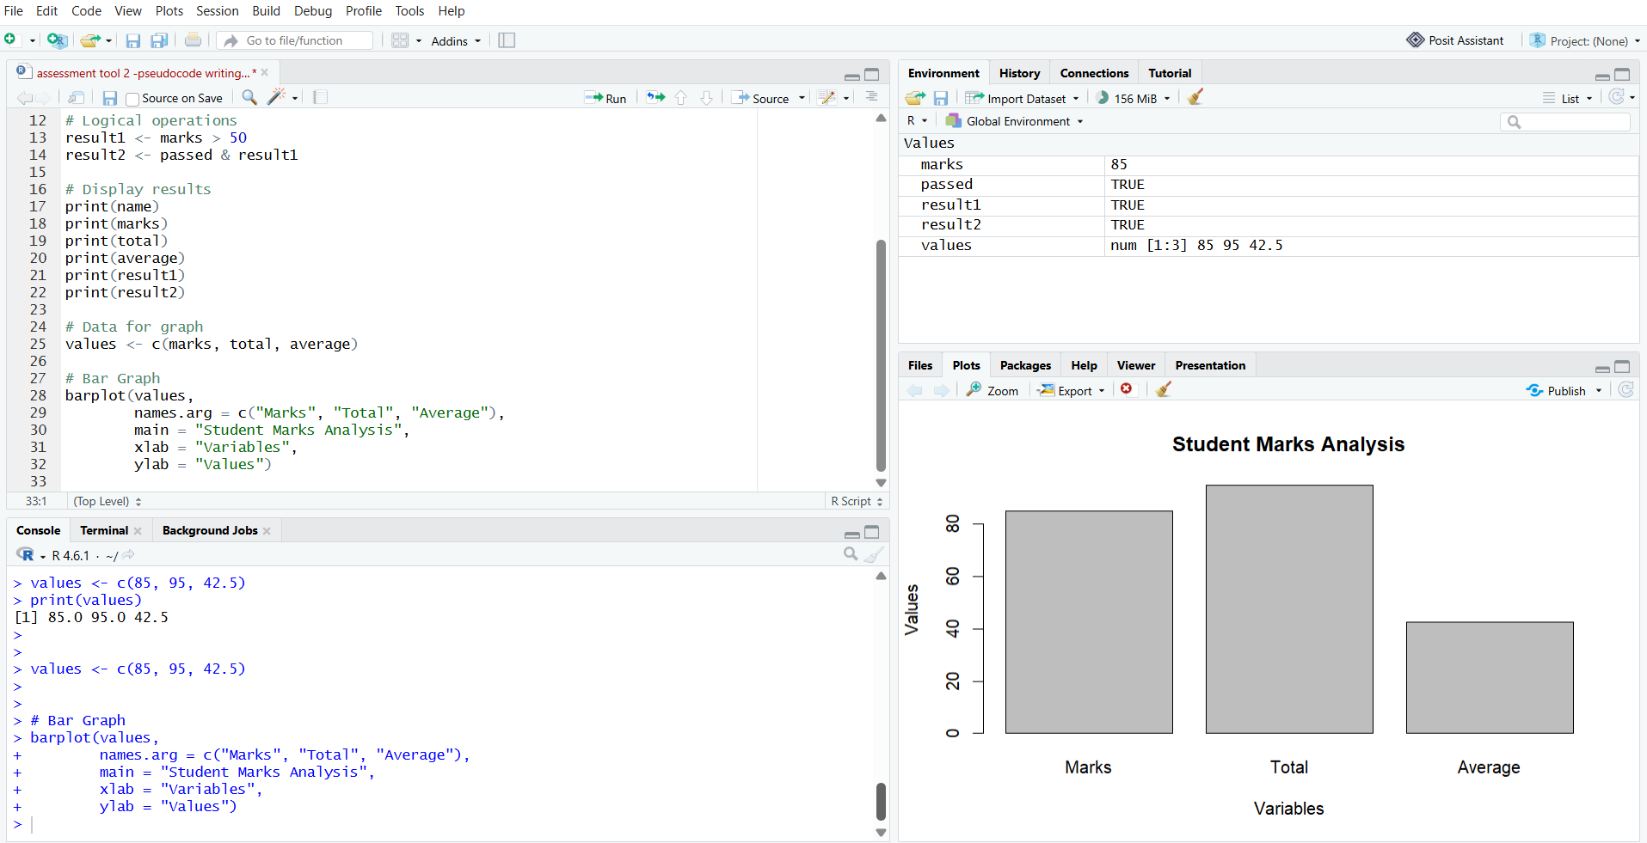

Q2. Data Structures Implementation
This question demonstrates vector, list, and matrix data structures. Indexing, updating, and aggregation operations are performed to understand their different uses.

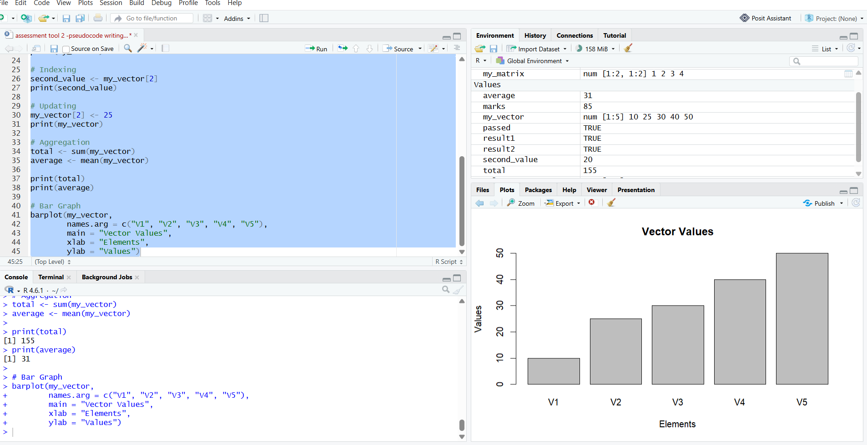

Q3. Matrix and Array Operations
This question demonstrates matrix addition, matrix multiplication, and element-wise operations. A 3D array is also created to understand multidimensional data.

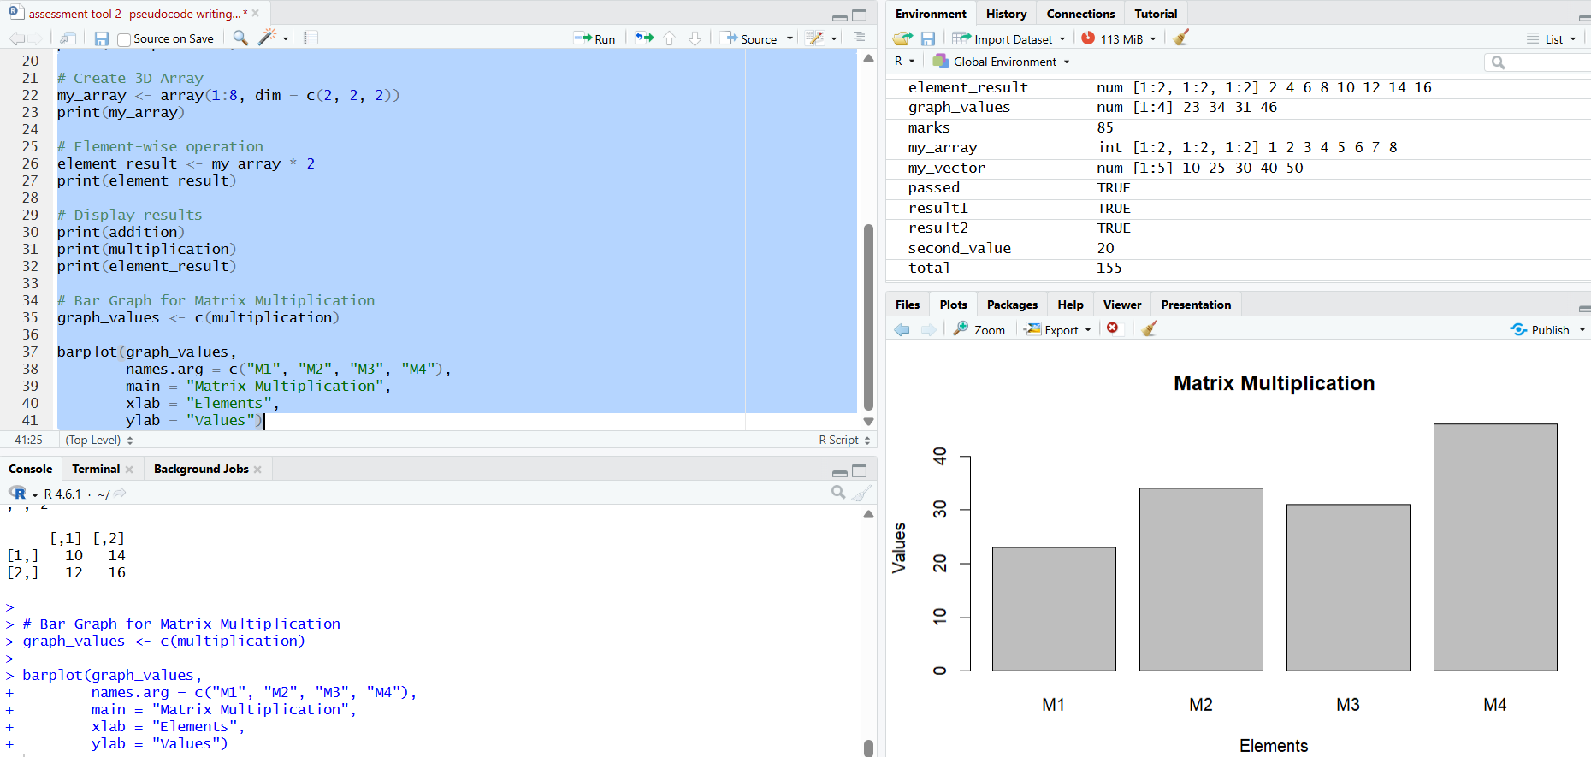

Q4. Data Frame Construction and Manipulation
This question demonstrates how to create and modify a data frame. Columns are added, deleted, and updated, and summary operations are performed.

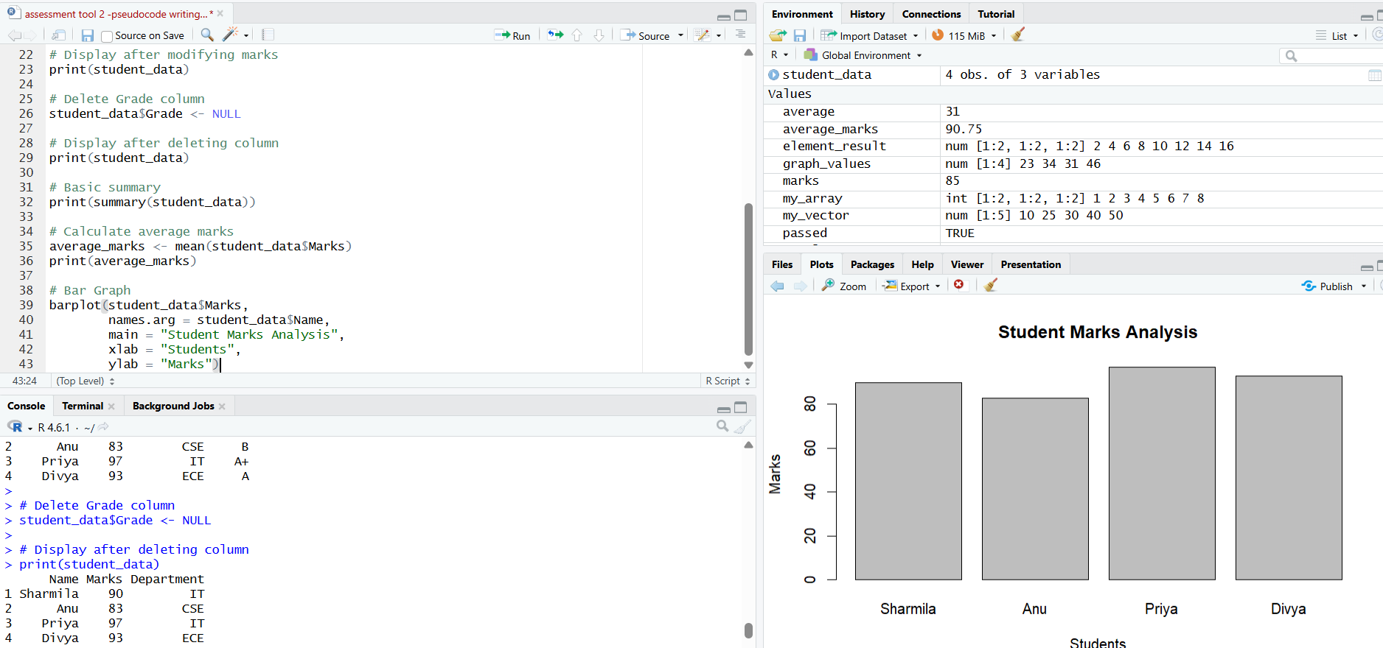

Q5. Functions and Logical Operations
This question demonstrates how to create a user-defined function and perform calculations. Logical vectors are used to check conditions and analyze the results..

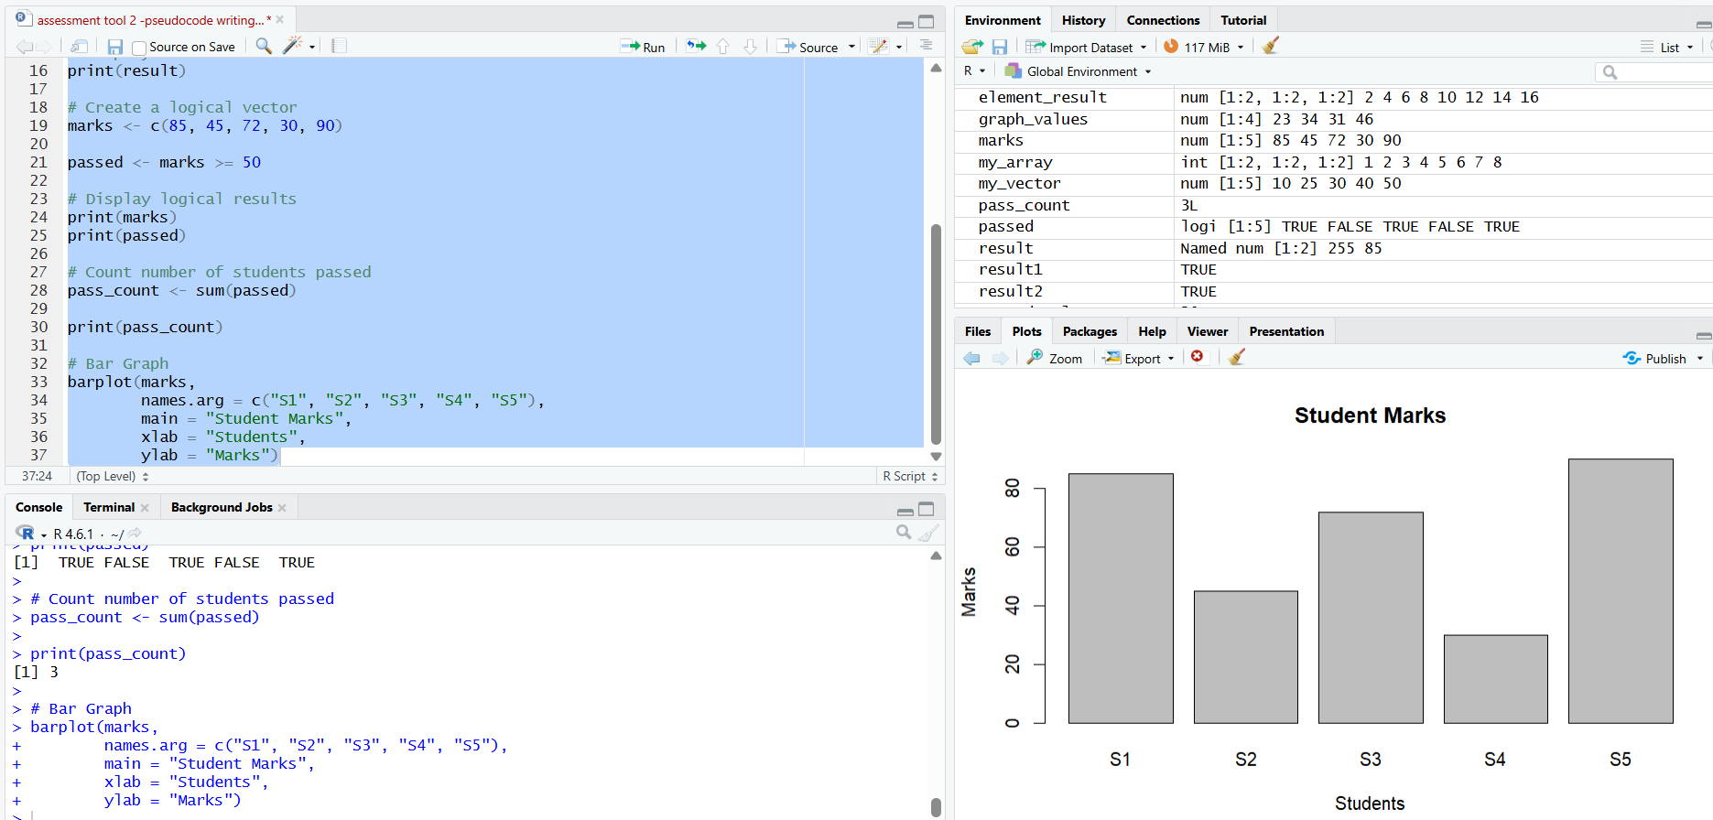

Rubrics for Calculations

